A.

Home Page.

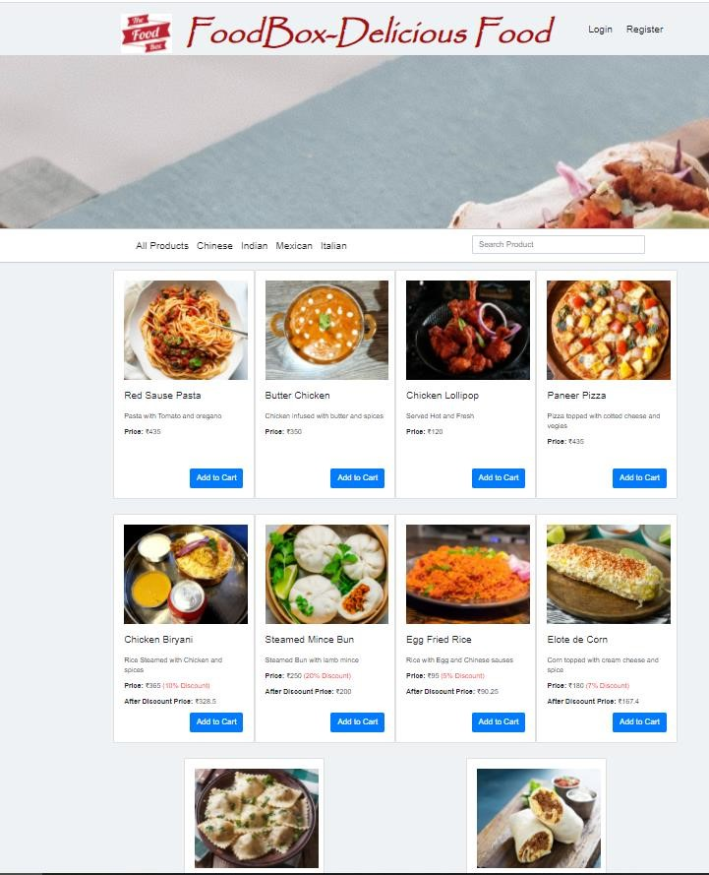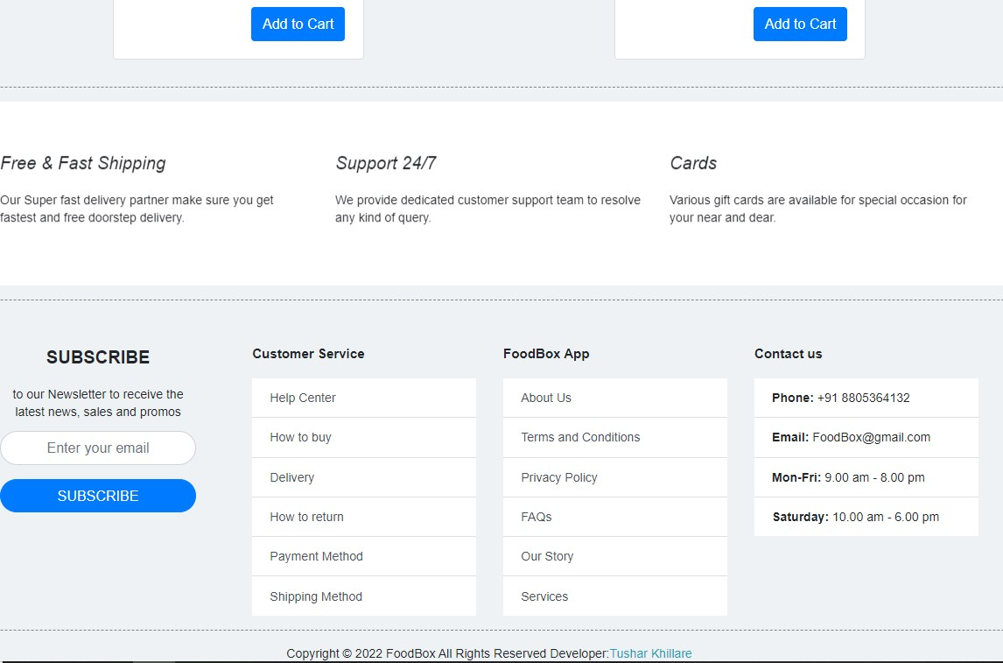

1. Admin Login Page.

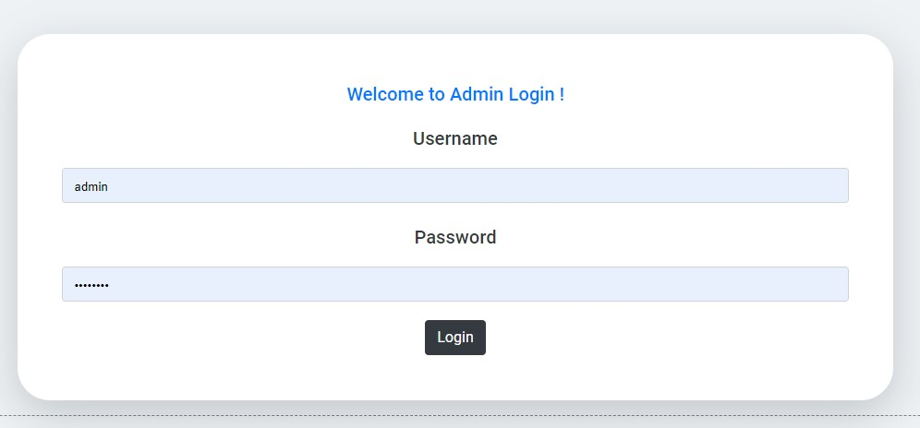

1. Manage Users , Products , Purchases.

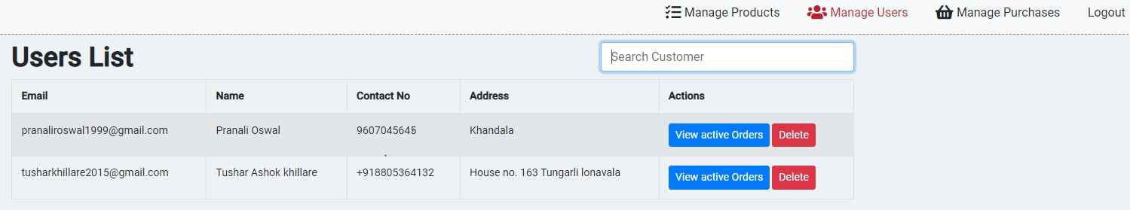

Searching and Sorting:

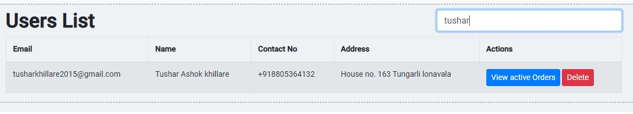

Manage Products:

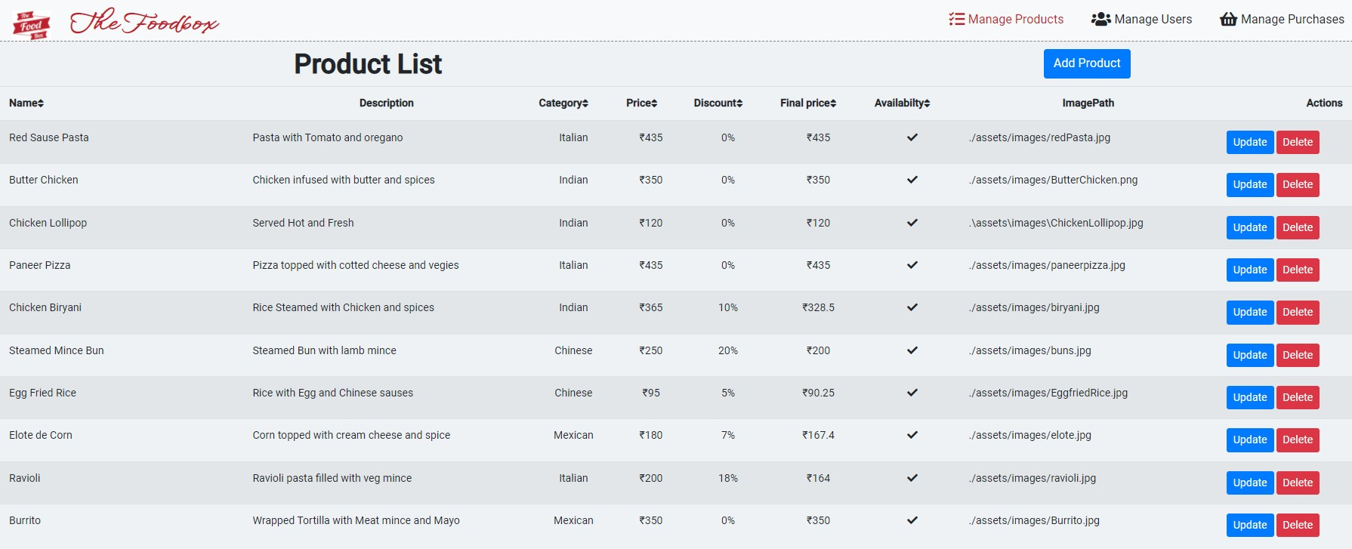

Add Product:

Update

Product:

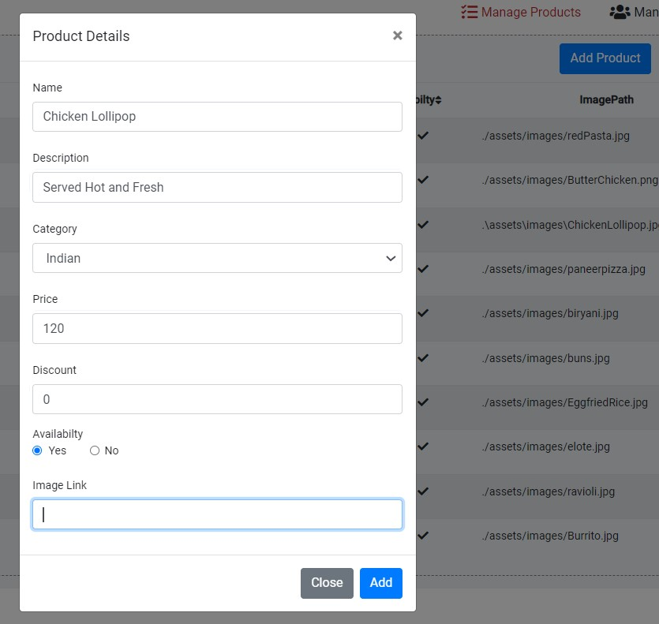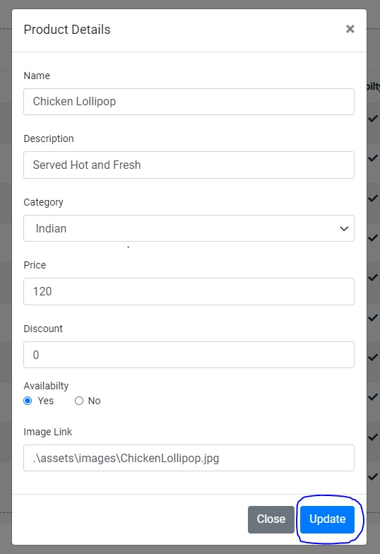

Product deleted successfully…..

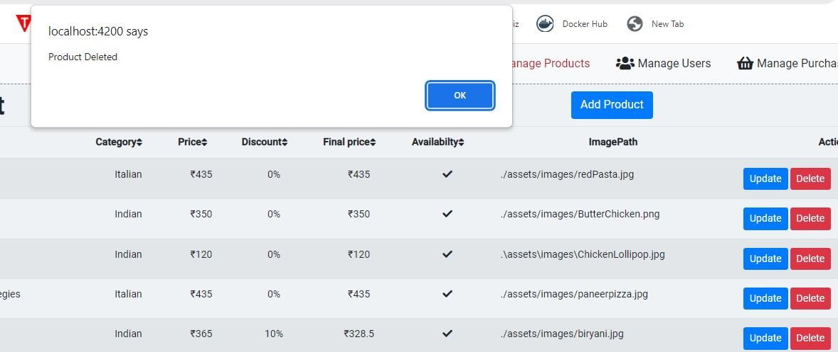

Manage Purchases:

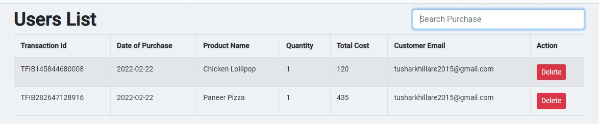

1. View Previous Active Orders.

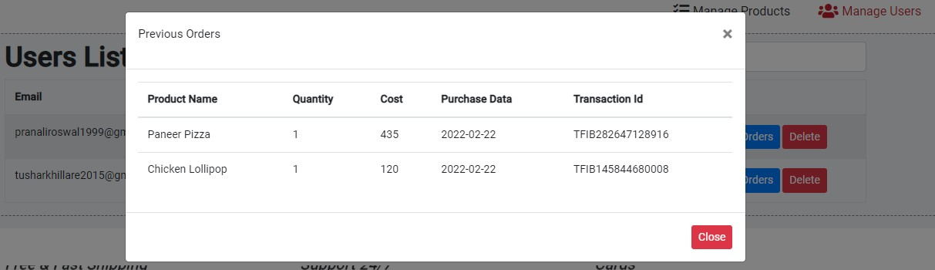

1. Add Cart / View Cart.

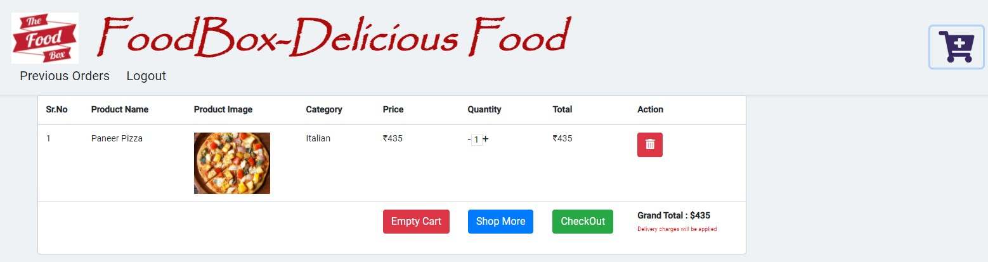

My Cart:

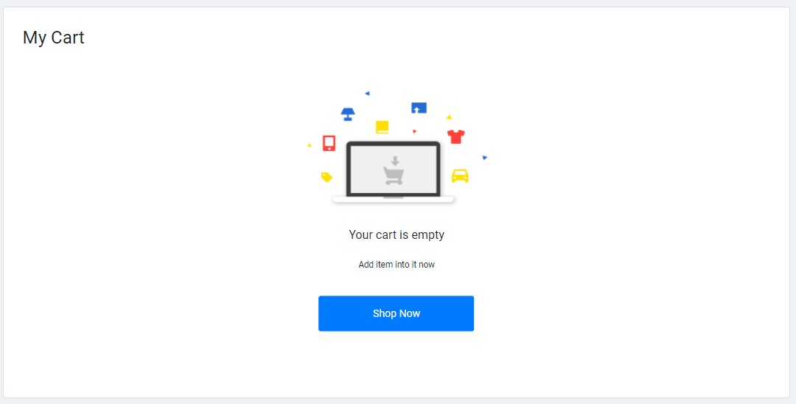

Payment Gateway Page.

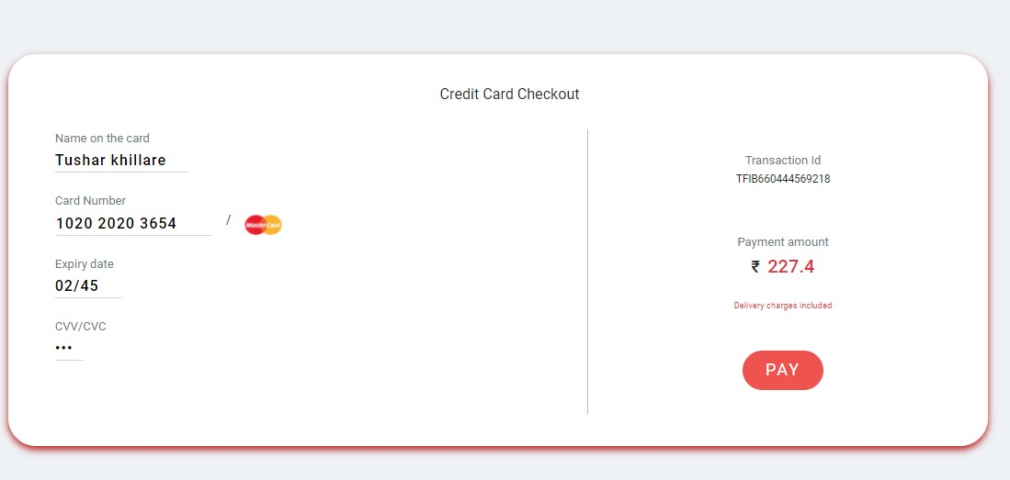

Payment Status:

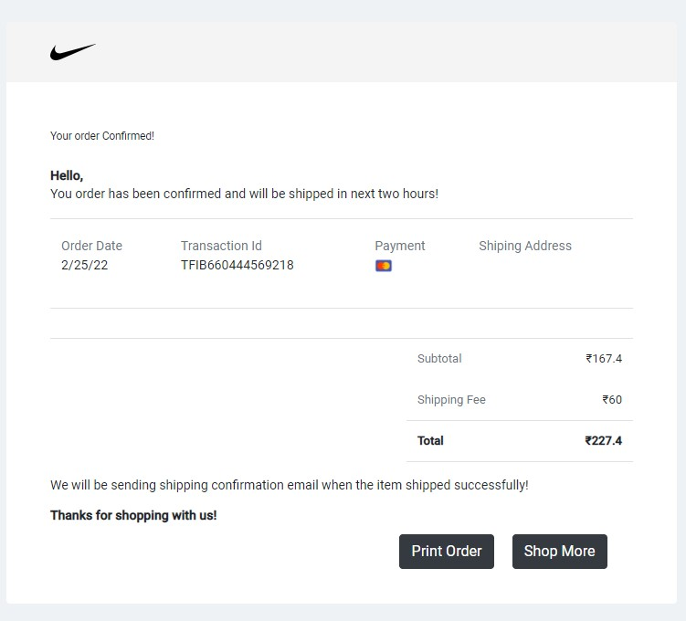

**TESTING AND DEVOPS USING JENKINS**

*Jenkins Build triggered successfully:*

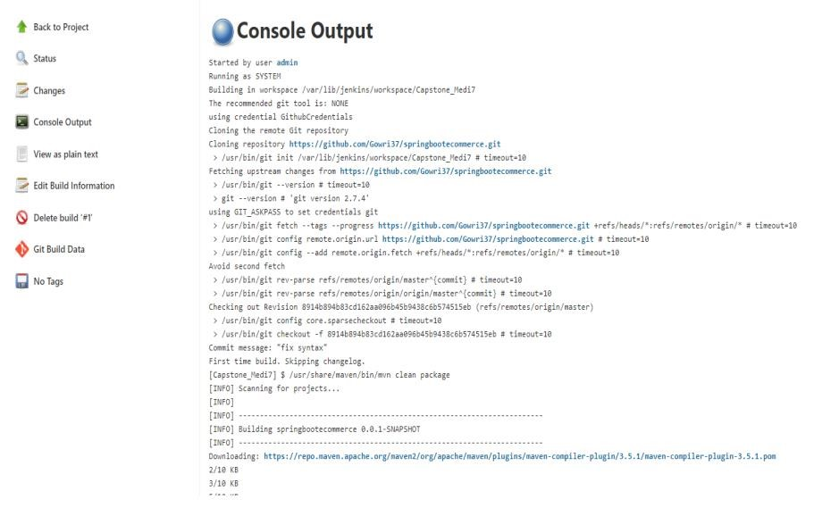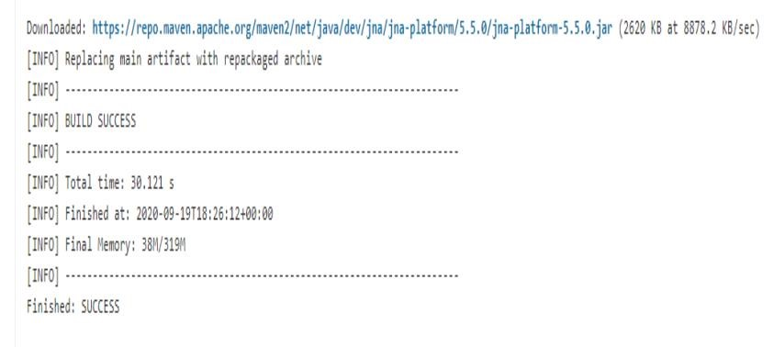

**PROJECT SCREENS POST TESTING AND JENKINS DEPLOYMENT**:

Category Based Searching

http://localhost:4200/products

